School Community Council Meeting  October 12, ,2016  1 – Welcome & Introductions  2 – Council Membership and Elections  - Please provide contact information  - Membership must be confirmed via email  3 – SCC Trainings  10-12, Bingham HS, 6:00  10-13, West Jordan MS, 6:00  10-26, Herriman HS, 6:00  10-27, JATC-S, 6:00  11-2, Riverton HS, 6:00  11-3, Copper Hills HS, 6:00  4 – Safe Technology and Digital Citizenship  5 – Report on Student Drop-off Procedures  6 – Student Pick-Up Procedures  - Concerns  - Recommendation for improvement  7 – 2015-16 Final Report Review  8 - Other | 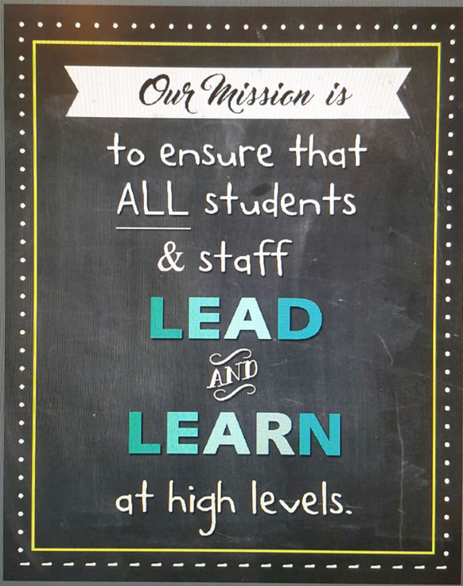

Give your best.
Read every day.
Own your mistakes.
Wonder!

