Final 2015-16 Land Trust Report - Rose Creek ES

Financial Proposal and Report

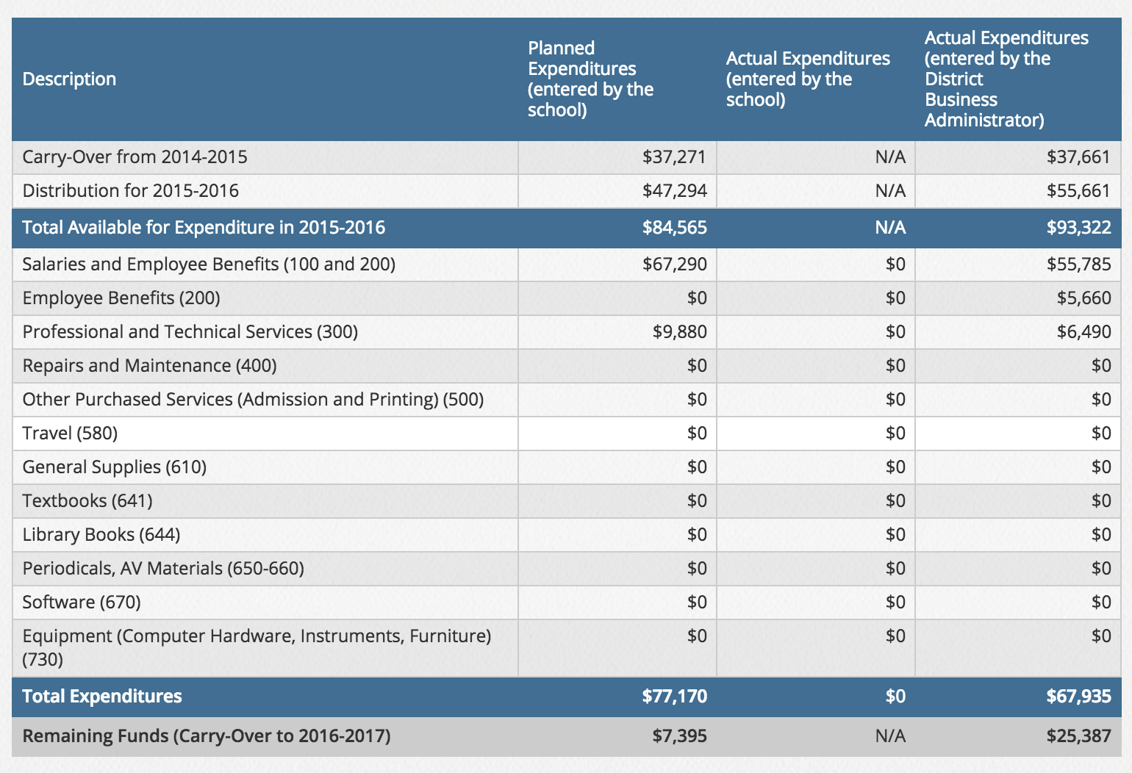

GOAL #1
GOAL

- Achieve one year's reading growth for 70% of all students by classroom in grades K-6 as
measured on PALS, Dibels, SRI and/or Guided Reading levels between August, 2015 and June, 2016.
- Increase the number of on or above level students in reading by 5% in grades K-6 as measured on PALS, Dibels, SRI, and/or Guided Reading levels between August, 2015 and June, 2016.
- Work toward lowering the size of student groups during tier II mathematics interventions between
August, 2015 and June, 2016.

MEASUREMENTS

This is the measurement identified in the plan to determine if the goal was reached.
Reading growth will be measured using PALS, Dibels, SRI and/or Guided Reading levels between August, 2015 and July, 2016. Math growth will be measured using pre and post assessment data administered during math intervention groups, benchmark data, and annual pre and post data on district assessments.

Before and after measurements and how academic performance was improved
SAGE proficiency scores maintained or grew from the previous year: Language Arts remained 48%, Mathematics was down 1% at 57%, and Science was up 4% at 53%.

READING DATA
Dibels in third-sixth grade was up 3% from 70% to 73%.

SRI was up 11% for sixth graders from 51% to 62%. (SRI was optional for other grades so data was inconsistent.)

Guided reading level growth was up 4% from 82% to 86% on or above level.

PALS was not administered. We used Dibels and it's accompanying program, Amplify, to determine student learning goals.

MATH DATA
District mathematics benchmarks (common assessments) showed a 54% growth grade school wide. Pre-test scores averaged 27% and post test scores averaged 80%. Grade level growth is indicated below.
Kindergarten: 85% growth
First Grade: 61% growth
Second Grade: 39% growth
Third Grade: 51% growth
Fourth Grade: 57% growth
Fifth Grade: 46% growth
Sixth Grade: 37% growth

ACTION PLAN STEPS

This is the Action Plan Steps identified in the plan to reach the goal.
Teachers will administer the Fountas and Pinnel assessment twice during the year, once in the Fall and again in the Spring. Additionally, teachers will use running records monthly to determine the guided reading level for each student. They will use the district leveling guided to determine grade level proficiency for each student. Data will be entered into J-SAS or Mastery Connect. Teachers, administration, and assistants will examine growth for each child based on this data. Teachers will administer the SRI exam three times a year: beginning, mid-year, and end of the year. They will use the grade equivalency band provided by the district to determine grade level proficiency for each student based on these assessments. Teachers, administration, and assistants will examine growth for each child based on this data. Teachers and district staff in grades 1-3 will administer the Dibels grade level assessment to determine progress toward grade level proficiency for all students at least three times per year. Administration will report the proficiency status to parents following the assessments. Teachers, administration, and assistants will examine growth for each child based on this data. Teachers will administer pre and post assessments using Math Expressions, district benchmarks, district annual pre and post grade level assessments, Mastery Connect or other Utah Core Standards aligned assessments to determine growth and proficiency. Teachers, administration, and assistants will examine growth for each child based on this data. These assessments will be used to determine students who are in need of tier II or III interventions. Five and possibly six assistants will be hired to either work with students in need of remediation or work with other students in the classroom so that teachers can work with struggling students. Assistants may also reduce class size by working with a group of students on a specified learning target based on data during math intervention time.

How the action plan was implemented to reach this goal
All assessments were given according to schedule. Teachers also administered weekly or bi-monthly assessments to determine student learning needs in mathematics and reading. Teachers examined results of data on a regular basis during PLC's.

Five assistants were hired to provide reading intervention instruction to students below grade level but not receiving Special Education services. Two assistants were hired to work with teachers during math tier II intervention time to provide more time and support for struggling students on targeted math standards.

A newsletter was sent to parents outlining achievement and growth based on SAGE testing information.

Teachers utilized Mastery Connect as a data review tool following assessment delivery. Intervention and acceleration groups were constructed based on Mastery Connect reports.
EXPENDITURES
Category | Description | Estimated Cost | Actual Cost
Salaries/Benefits | Salaries | $46,000 | $48,542

GOAL #2
GOAL

Increase faculty knowledge of the purpose and practice of professional learning communities by attending the Professional Learning Communities at Work Institute in November, 2015. As a result, the effectiveness of professional learning communities should increase over$48,542 the 2015-16 school year. Faculty members will participate in extended PLC's in order to provide a viable and guaranteed curriculum for all students.

MEASUREMENTS

This is the measurement identified in the plan to determine if the goal was reached.
The effectiveness of PLC's will be measured by student growth and achievement on SAGE testing, pre and post testing in mathematics, guided reading levels, PALS, Dibels, and SRI testing. Additionally, during extended PLC's, teacher teams will begin creating core driven units aligned to rigorous assessments to be implemented in the 2016-17 school year.

Before and after measurements and how academic performance was improved.

SAGE proficiency scores maintained or grew from the previous year: Language Arts remained 48%, Mathematics was down 1% at 57%, and Science was up 4% at 53%.

READING DATA
Dibels in third-sixth grade was up 3% from 70% to 73%.

SRI was up 11% for sixth graders from 51% to 62%. (SRI was optional for other grades so data was inconsistent.)

Guided reading level growth was up 4% from 82% to 86% on or above level.

PALS was not administered. We used Dibels and it's accompanying program, Amplify, to determine student learning goals.

MATH DATA
District mathematics benchmarks (common assessments) showed a 54% growth grade school wide. Pre-test scores averaged 27% and post test scores averaged 80%. Grade level growth is indicated below.
Kindergarten: 85% growth
First Grade: 61% growth
Second Grade: 39% growth
Third Grade: 51% growth
Fourth Grade: 57% growth
Fifth Grade: 46% growth
Sixth Grade: 37% growth

ACTION PLAN STEPS

This is the Action Plan Steps identified in the plan to reach the goal.
Team leaders will gain a greater understanding of professional learning communities by attending the Professional Learning Communities at Work Institute to be held November 16-18, 2015 in Salt Lake City, Utah. (Team members include 7 grade level, 2 Special Education, and 1 administrative representative). Following the conference, attendees will report back to their team and apply at least two things learned in the conference in their own PLC. Teachers attending other conferences will be expected to share their learning with the faculty and apply learning in their own classrooms. Additionally, data will be examined at least twice a month during PLC's to measure student growth and achievement. Expenditures for this action plan include conference registration and substitute costs. Extended PLC's will be held in the spring as a follow-up to the PLC conference. Teams will have two days to create core driven units aligned to rigorous assessments to be implemented in the 2016-17 school year. (Land Trust funds will pay for one of the two days.) Substitute costs will be the only expenditure for this portion of the action plan.

How the action plan was implemented to reach this goal.
Team members attended the Professional Learning Communities at Work Institute in Salt Lake City, November 16-18, 2015. Team members included the team leaders from K-6th grade, a Special Education teacher, a BYU Facilitator, and administrator. Funding covered substitute costs and registration fees.

A half day team meeting was held on the final day of the conference to synthesize conference learning. At that time, a mission statement was written. Additionally, team members determined values, vision, and goals for the year. Some of those goals required additional time for teachers to create common curriculum maps and shared common formative assessments. These were created the following spring during extended PLC's.

PLC work continued to focus on the four foundations of effective PLC's: mission, vision, values, and goals. Teams also continued to address the four guiding questions: What do we want student to know or be able to do? How will we know if they know it or can do it? What will we do if they don't know it or can't do it? What will we do if they already know it or can do it? Responding to these questions led to consistent tier II intervention in mathematics. Sustained math proficiency was out outcome of focused PLC work.

EXPENDITURES
Category | Description | Estimated Cost | Actual Cost
Salaries/Benefits | Stipends and substitutes | $11,490 | $12,903
Professional | Conference registrations | $6,690 | $6,490

GOAL #3
GOAL

Improve tier I, II, and III instruction in mathematics through focused professional development over the course of the 2015-16 and 2016-17 school years.

MEASUREMENTS

This is the measurement identified in the plan to determine if the goal was reached.
The effectiveness of the mathematics professional development will be measured by student performance on SAGE testing, district benchmark testing, and grade level common assessments. An increase of at least 5% should be evident in SAGE and district testing for the overall school score. Grade level testing should reveal growth between pre and post testing. Additionally, all faculty members will take an assessment (IMAP) about teaching mathematics to children at the beginning of the professional development and again at the end of the training to determine growth in teacher understanding of both pedagogy and elementary mathematics. The assessment has been developed through CITES and the BYU Math Partnership. Additionally, the professional development materials and program were developed by the same committee and will be used in this setting.
Please show the before and after measurements and how academic performance was improved.
The SAGE mathematics proficiency score was 57% this year, down 1% from last year. The 2014 score was 44%. This represents a 33% growth in proficiency in the past three years. Ultimately, 2015 and 2016 scores are similar and represent a stabilization in achievement.

Evidence that students are learning mathematics is found in the growth reported with pre and post testing.
GROWTH PROFICIENCY (Post)
Kindergarten 85% 92%
First Grade 61% 93%
Second Grade 39% 81%
Third Grade 51% 79%
Fourth Grade 57% 79%
Fifth Grade 46% 72%
Sixth Grade 37% 66%

All teams used common assessments created by the team or those found on Mastery Connect to determine student progress. This was done at weekly or bi-monthly intervals.

ACTION PLAN STEPS

This is the Action Plan Steps identified in the plan to reach the goal.
Faculty members who have not completed the IMAP assessment will complete it prior to beginning the training at the beginning of the 2015-16 school year. Faculty members will participate in eighteen two-hour sessions over the course of the school year. A lesson study will be conducted in the spring of 2016. Expenditures for this program include the cost of substitutes and stipends for teachers attending while off-track. The cost of this training is being split three ways: Rose Creek Land Trust, MSP grant through BYU, and the JSD Curriculum Department.

How the action plan was implemented to reach this goal
Faculty members engaged in eighteen two-hour professional development sessions over the course of the year along with a successful lesson study. The professional development sessions focused on two areas: mathematics and mathematics instruction. A focus on mathematics was necessary to increase teacher's depth of knowledge, thus making them more able to understand student thinking. The second focus of the professional development was on effective instruction in a mathematics classroom. Teachers learned about the teaching and learning cycles and then applied their understanding in a lesson study experience. Each team wrote a mathematics lesson designed to surface student thinking about a specified concept. One teacher was selected to conduct the lesson while the rest of the team observed students engaging in the task. A debriefing session was held following the lesson where teachers examined student thinking and understanding in depth. They were then able to modify the lesson in order to increase effectiveness.

The cost of the training and substitutes/stipends was covered entirely by an MSP Grant through BYU.

EXPENDITURES
Category | Description | Estimated Cost | Actual Cost
Salaries/Benefits | Stipends and substitutes | $8,000 | $0

GOAL #4
GOAL
Increase student capacity to see themselves as learners and achievers by continuing to implement the Leader in Me program.

MEASUREMENTS
This is the measurement identified in the plan to determine if the goal was reached.
Improvement in growth and achievement will be evident in data notebooks created used throughout the school year by each student. All students will report on their own growth in at least one area during a year-end celebration.

Before and after measurements and how academic performance was improved.
Data was collected. However, we were not able to attend the training so there is no correlation between student data notebooks and conference attendance.

ACTION PLAN STEPS

This is the Action Plan Steps identified in the plan to reach the goal.
The Lighthouse Team, the governing committee for the Leader in Me program at Rose Creek, will attend the Leader in Me Symposium in the spring of 2016. (Lighthouse Team members include 7 grade level, 2 Special Education, and 1 administrative representative.)

How the action plan was implemented to reach this goal.
The Leader in Me Symposium was held in Las Vegas, Nevada this past year. (The location was announced after the deadline for submitting the Land Trust plan. Prior to this year, it has been held along the Wasatch Front.) It was held at the same time as parent-teacher conferences. We didn't have adequate funds for travel and lodging. Additionally, timing wasn't right for us to attend because of PT conferences. We did not attend the Symposium.

While team leaders were unable to attend the Symposium, we continued to focus on the 7 Habits. All new staff members attended a 7 Habit course. We also held a family night in February focused on the habits. Students utilized data notebooks to monitor their learning.

Additionally, coaching was provided for Lighthouse Team members. This was done through Franklin Covey.

EXPENDITURES
Category | Description | Estimated Cost | Actual Cost
Salaries/Benefits | Stipends and substitutes | $1,800 | $0
Professional | Conference registrations | $3,190 | $0

INCREASED DISTRIBUTION
The school plan describes how additional funds exceeding the estimated distribution would be spent. This is the description.
Where possible, we will hire additional math assistants to support tier II instruction. This will allow us to make smaller groups for students needed the most help.
Description of how any additional funds exceeding the estimated distribution were actually spent.
We will use increased distribution to cover costs associated with extended PLC's in the spring. All teacher teams are given work days to complete curriculum maps, fine tune assessments, and prepare for the upcoming school year. Extra funds will pay for substitute costs or stipends for attending during the summer.

